NAME………………………………………………………………………………………..
KIKONGE HIGH VIEW SECONDARY SCHOOL
SENIOR TEST 1 TERM 2 2023
BIOLOGY
TIME: 50 MINUTES
INSTRUCTIONS: ATTEMPT ALL IN THE SPACES PROVIDED
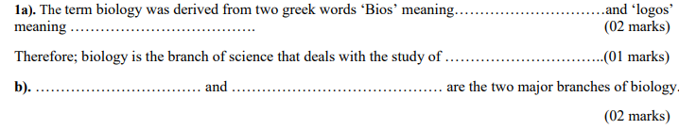
. All living organisms were scientifically named according to the Binomial Nomenclature system discovered by cardus Linnaeus. This system gives scientific names to organisms with two parts namely the genus names and species name.
a) Complete the table below by filling in the most correct genus name, species name or scientific name of the organisms in the blank spaces below. (03 marks)
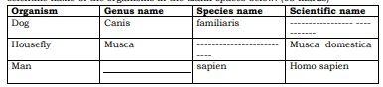
b) State any three rules observed/ followed while writing scientific names of organisms. (03 marks)
….………………………………………………………………………………………………………………………………………………………………………………………………………………………………………………………………………………………………………………………………………………………………………………………………………………………………………………………………………………………………………………………………………………………………………………………………………………..

